# Cities around the world are adding more bus lines but KL is special, we’re getting rid of them! Here’s how that’s bad

On November 19, 2020, RapidKL announced via Twitter that they were terminating bus routes 754, 781, 852, T204, T784 and E1 which will come into effect in two weeks on December 1st 2020.[1]



This very short-noticed nature of the announcement, coupled with the lack of good alternatives led to quite noticeable complains online (where else would Malaysians complain right). There was even a petition going around hoping to keep the route. But to no avail, the they were still cancelled. **I** felt sorry for the people affected but was curious on how bad can the alternatives be? Were the cancellations justified? Were there reasonable alternatives available? This was prompted my investigation.

## Choosing a route to start digging into

The cancelled routes cover a variety of different areas including Titiwangsa, Dutamas, Petaling Jaya and Shah Alam. The route that caught **my** attention the most was **route 852.** Here’s a screenshot of a map to visualize its route. 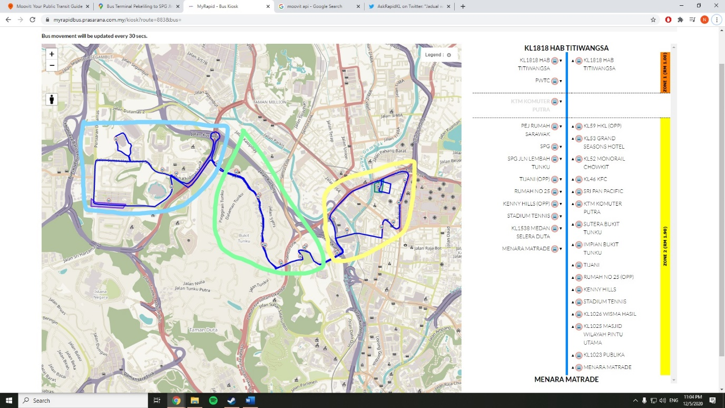

The dark blue line in the map represents the bus’s path. Users would use this bus to get around between the areas, Titiwangsa (Yellow), Bukit Tunku (Light Green) and Dutamas (Light Blue). Based on several different anecdotes on Twitter (user @FikahMus has since private her account), users tend to commute from stops in the Titiwangsa area to get to work in Bukit Tunku and Dutamas. Without the 852 bus, they will now have to take alternative routes.

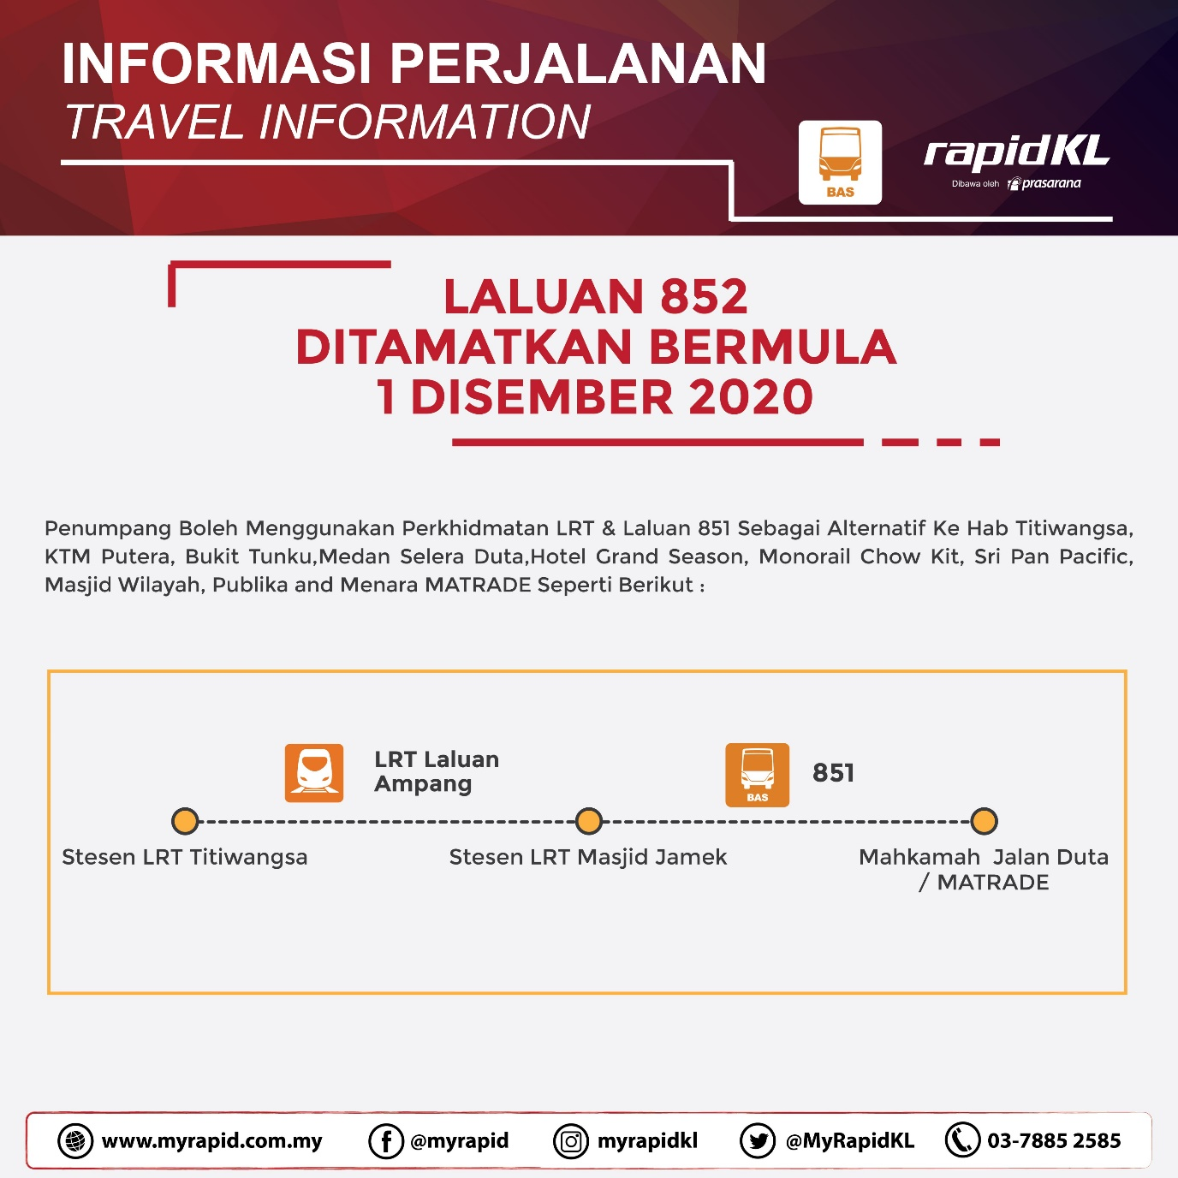

RapidKL suggested this alternative. Take the LRT Titiwangsa to Masjid Jamek. Then change to the 851 bus. BUT, according to a BFM interview with Mak Cik Amir, a user, on top of the longer travel time on the LRT and 851 bus, because no other route covers Bukit Tunku, she will have to walk an additional **20 minutes!** This all sounds horrible, but how bad is it? Can we objectively put a number into how much worse the alternatives are and ultimately are the cancellations justified in terms of user experience? This is when I really got to work.

## Here’s how it’s done

We’ll use a combination of Google Maps and Moovit to figure out travel times along the cancelled routes. If you’re unfamiliar with Moovit, it’s the most complete public transport journey planner in Malaysia. So, the idea is that Moovit will be able to provide the widest range of alternatives of travel along the cancelled bus routes. Here’s an example going from the Hab Titiwangsa bus stop to the Publika bus stop.

. 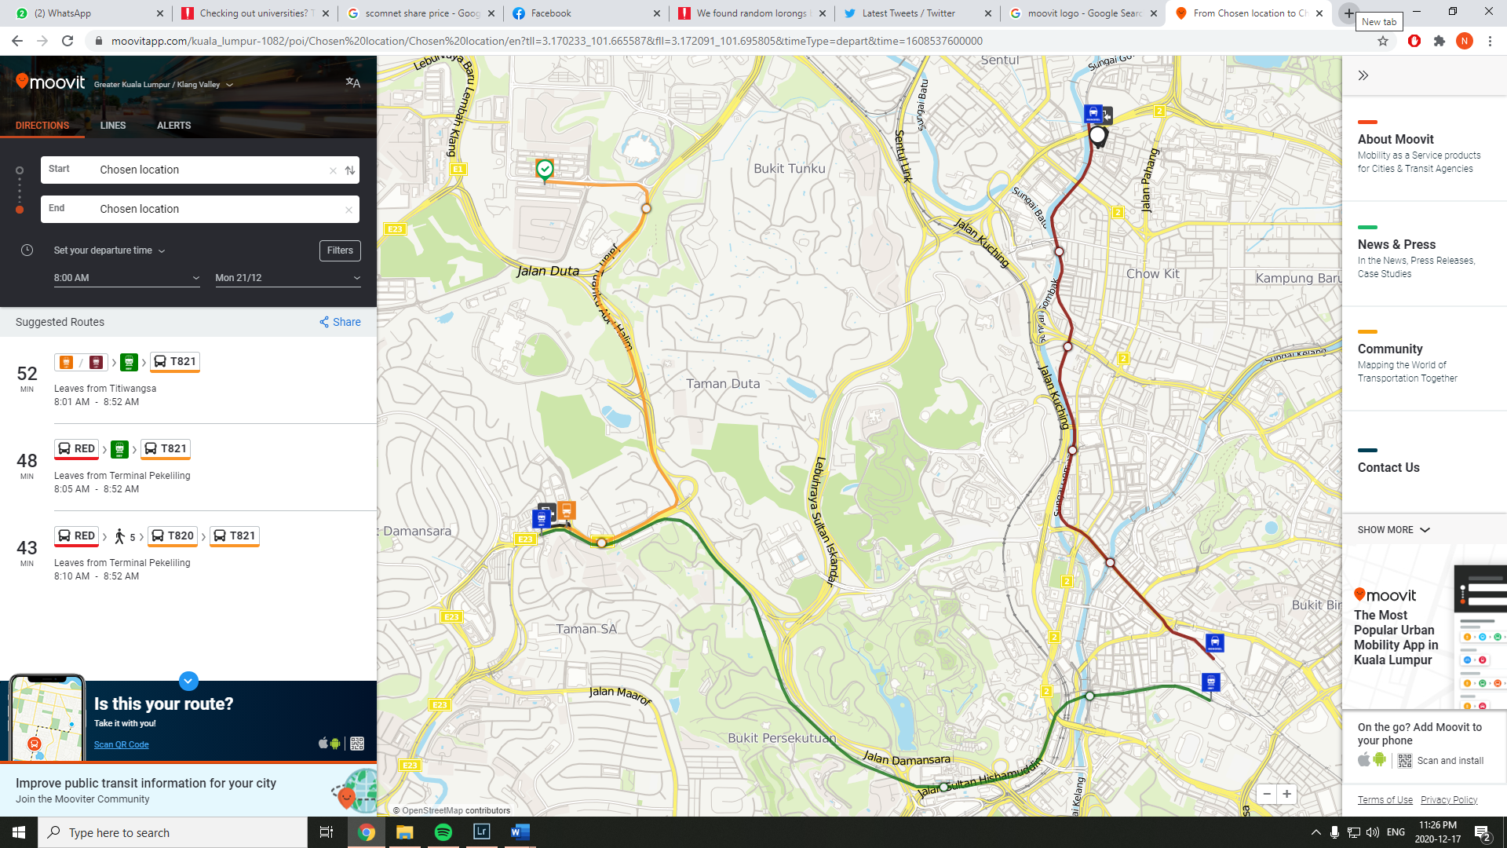

As you can see, there are multiple travel alternatives. However, the terminated lines are no longer active on Moovit ☹. So, I had to do the next best thing which is to simulate the journey using Google Maps, navigation feature. I drew points on the map for the navigation app to follow and just took the journey times from bus stop to bus stop. This will give a reasonable estimate for the travel times of the now cancelled bus routes. Heres a map below of a sample, again simulating going from the Hab Titiwangsa bus stop to the Publika bus stop.

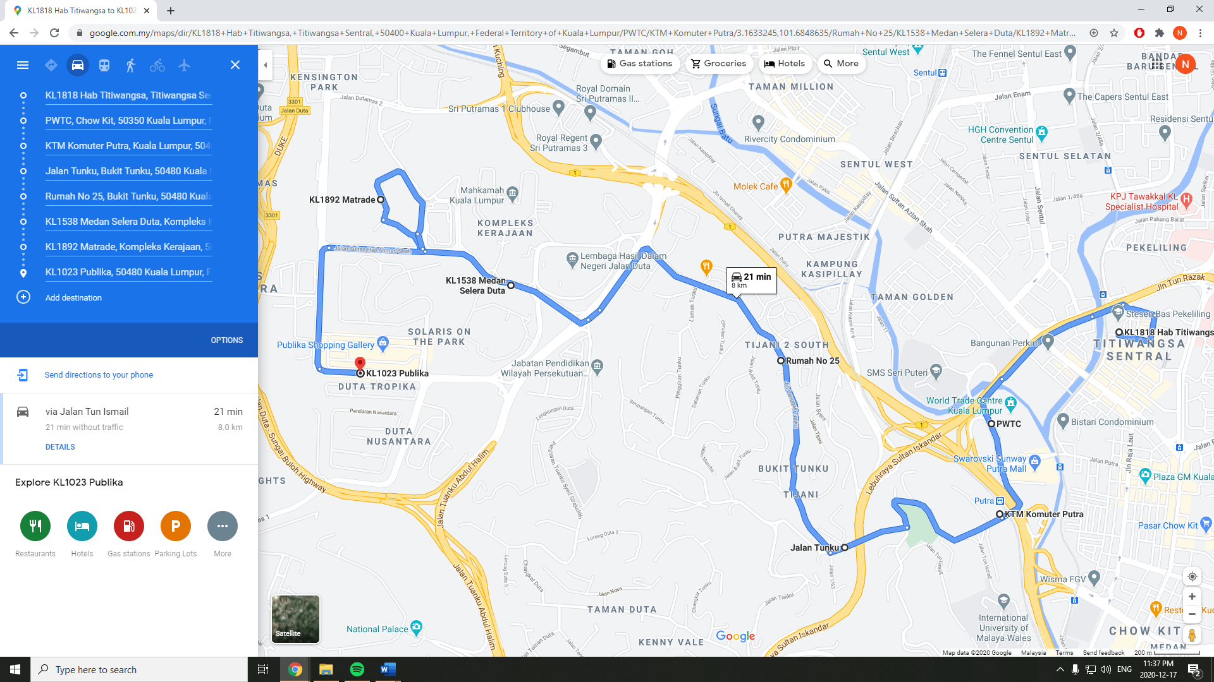

Now that the tools to figure out the travel times have been sorted out, I need to set parameters to investigate because if I were to do every single bus stop throughout the day then I’ll pengsan. So, I standardized the arrival time to be at 8am to simulate people trying to get to work on time. I also chose only a few stops to investigate. For example, for the 852 bus route, only 2 stops within the Titiwangsa area were chosen as starting points for users trying to get in Bukit Tunku and Dutamas. Then rinse and repeat for the other bus routes.

## Phew that’s all the technical parts out of the way. Time for the fun part. Charts and Pictures!

|  |  |  |  |
| --- | --- | --- | --- |
| **852 Route** | **852 Bus** | **Alternative Moovit Times + wait** | **Walk** |
| KL1818 HAB TITIWANGSA to KENNY HILLS (OPP) | 8 | 31 | 24 |
| KL1818 HAB TITIWANGSA to KL1023 PUBLIKA | 18 | 33 | 2 |
| KL1818 HAB TITIWANGSA to KL1025 MASJID WILAYAH PINTU UTAMA | 20 | 32 | 8 |
| KL1818 HAB TITIWANGSA to MENARA MATRADE | 13 | 40 | 7 |
| KL1818 HAB TITIWANGSA to SPG JLN LEMBAH TUNKU | 5 | 34 | 21 |
| KL1818 HAB TITIWANGSA to STADIUM TENNIS | 9 | 27 | 20 |
| KL1818 HAB TITIWANGSA to TIJANI (OPP) | 6 | 38 | 25 |
| KTM KOMUTER PUTRA to MENARA MATRADE | 10 | 48 | 10 |
| KTM KOMUTER PUTRA to STADIUM TENNIS | 6 | 32 | 23 |
| KTM KOMUTER PUTRA to KENNY HILLS (OPP) | 5 | 32 | 32 |
| KTM KOMUTER PUTRA to KL1023 PUBLIKA | 15 | 43 | 1 |
| KTM KOMUTER PUTRA to KL1025 MASJID WILAYAH PINTU UTAMA | 17 | 40 | 5 |
| KTM KOMUTER PUTRA to SPG JLN LEMBAH TUNKU | 2 | 14 | 14 |
| KTM KOMUTER PUTRA to TIJANI (OPP) | 3 | 18 | 18 |
| **Average** | **9.79** | **33** | **15** |

Here’s a table of the travel time using the 852 route. On average, travelling from Titiwangsa to Bukit Tunku or Dutamas at 8am would take around 10 minutes. But the fastest its alternatives can do, on average takes 33 minutes. So the alternatives takes 3 times longer than the original cancelled route. On top of that, some of the alternatives include a lot of walking. The worst is getting from KTM Putra to Kenny Hills, which is an entirely 32 minute walk because there are no faster alternative.

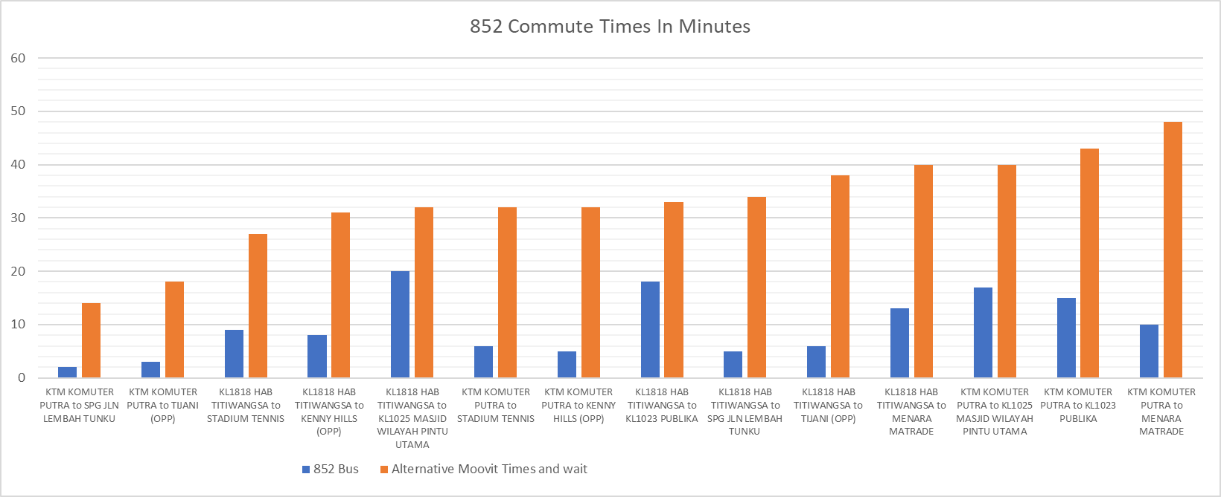

1. https://twitter.com/AskRapidKL/status/1329318561370701826?s=20